APPENDIX D — NAVIGATION AND ERROR CHECKS

Content Uniformity / Sampling Plan 1
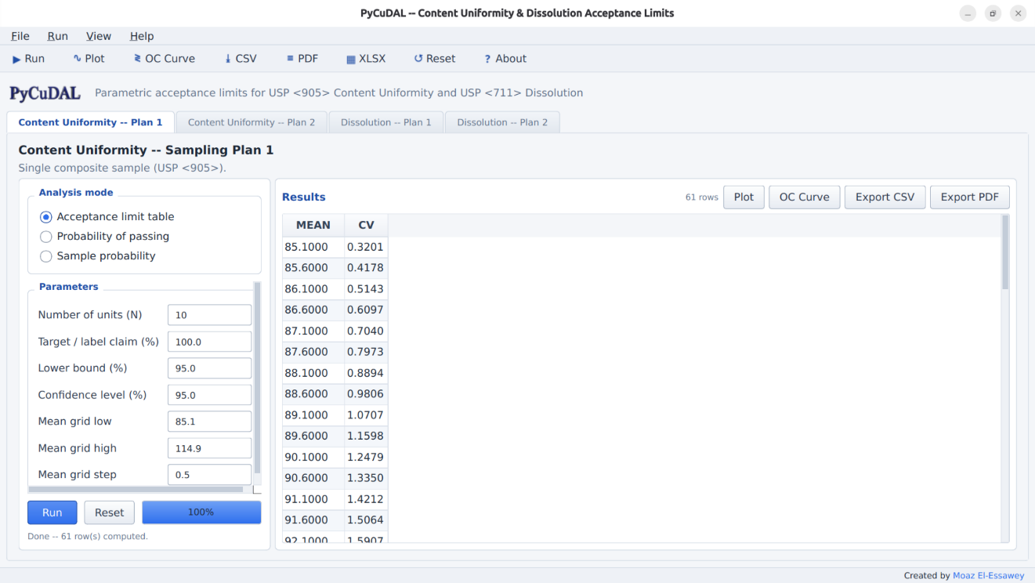

Content Uniformity / Sampling Plan 2

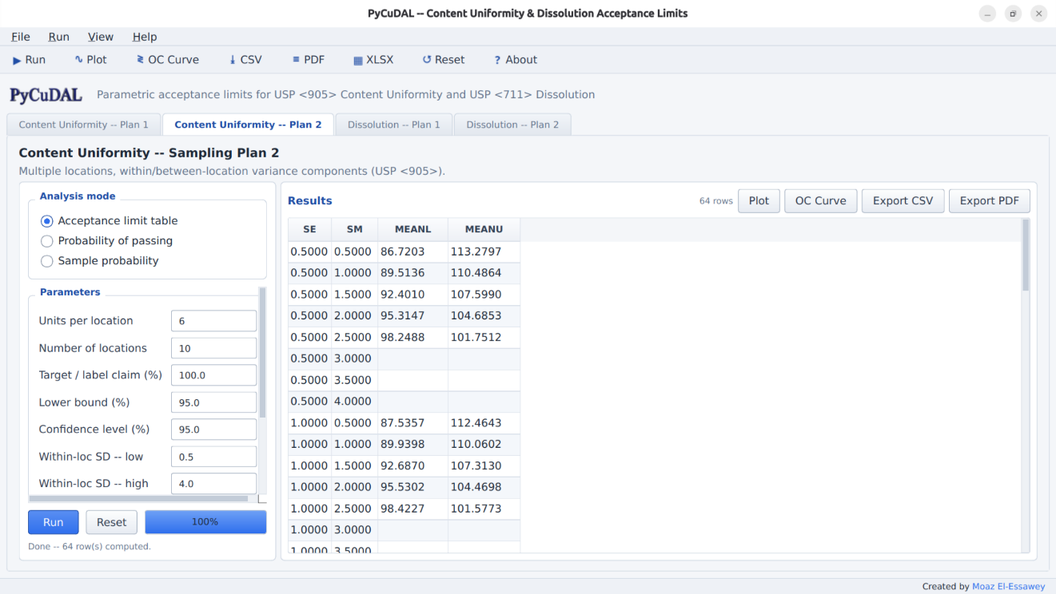

Dissolution / Sampling Plan 1

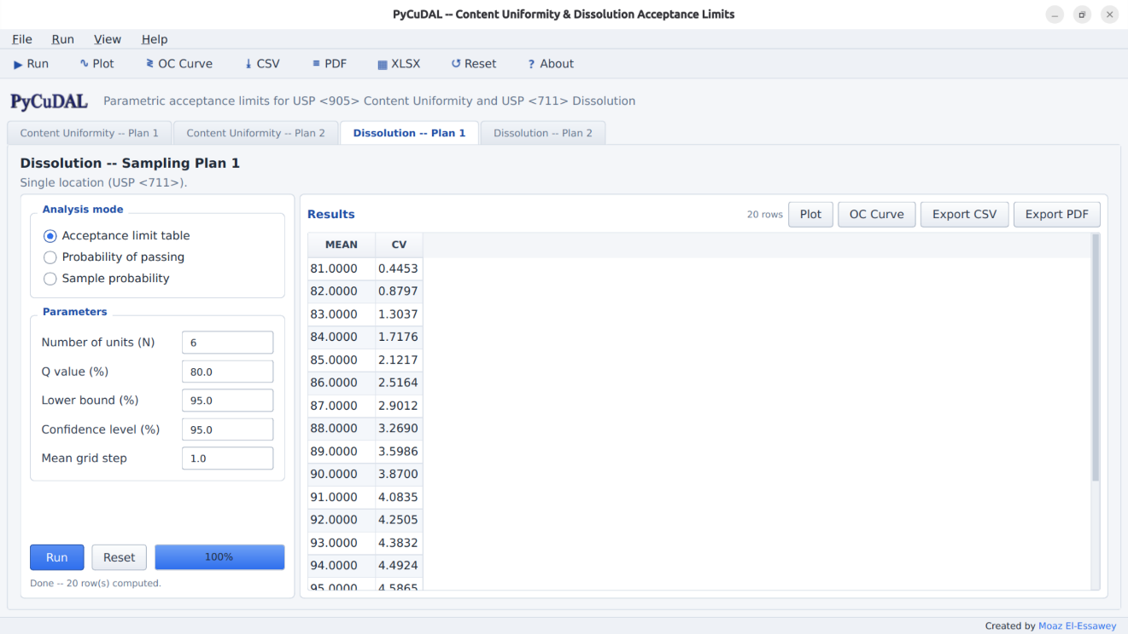

Dissolution / Sampling Plan 2

